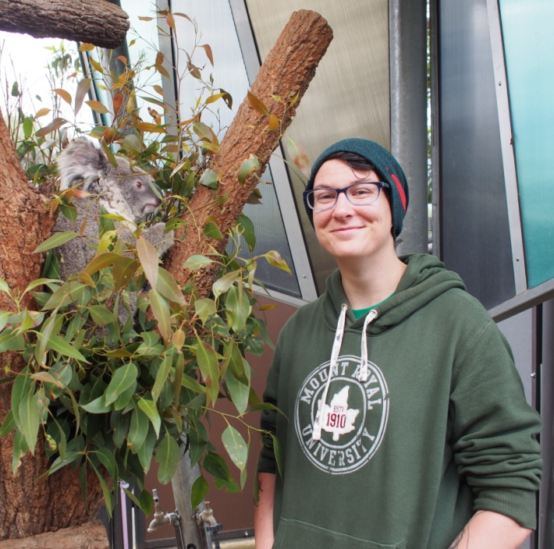
Nadin Boegelsack
Calgary, Alberta, Canada
I would like to thank the Royal Society of Chemistry for providing a travel grant to attend the INEF 2017 conference in Beijing, China, and present my budding research there. It was a wonderful experience to network internationally and to broaden my understanding of current research in a multitude of areas, ranging from up-coming instrumentation over statistical analyses to the importance of moral integrity in science, all of which will indubitably be of use over the course of my PhD.
My research focuses on the analysis of ignitable liquid residue (ILR) in wildfires. I am currently in the literature review phase; therefore, I presented an overview of the importance of ILR analysis in wildfire investigations, as well as a summary of past, current and emerging analytical techniques and their associated problems. Hopefully, by the time the next INEF conference comes around, there will be some interesting findings on the statistical analysis of multidimensional chromatography data to be presented!
Besides the conference itself, the opportunity to go sightseeing to the Great Wall and Forbidden City, all while socializing with likeminded people, certainly made for a great trip altogether. Thank you once again to the RSC and INEF for providing a generous travel grant to allow students from all over the world to attend this thought-provoking and enjoyable conference!

