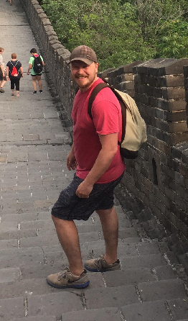
Kevin Hayes
Mount Royal University, Calgary Alberta, Canada
It was an incredible honor to receive a Travel Grant from the Royal Society of Chemistry, which allowed me to attend INEF 2017 conference in Beijing, China! The conference itself was an incredible experience. The opportunity to meet and talk with experts and other students within the field of Environmental Forensics was amazing! The speakers at the conference were very informative and I feel I learned a great deal more about the field than I had known prior to attending.
The conference also allowed me to describe a case study that I was interested in. The study involved a scenario in which petroleum biomarkers were used to determine if hydrocarbons found on an abandoned oil well site in Alberta were of phytogenic or petrogenic origin. The use of this technique allowed for lower cost and reduced disturbance when reclaiming the site, and I felt demonstrated how useful Environmental Forensics could be in real world application. This usefulness was further demonstrated by the great variety of excellent posters presented by fellow students, as well as, experts attending the conference!
This conference is not one that will soon be forgotten. On top of the informative speakers, there was also the chance to see some of the amazing sights that Beijing had to offer, beautiful accommodations, and delicious food. I am very excited to hopefully attend INEF conferences in the future! I would like to send my most sincere thanks to the Royal Society of Chemistry and to the INEF 2017 selection committee for providing me with this wonderful opportunity!

